

Student Name……………………………………

FURTHER MATHEMATICS

TRIAL EXAMINATION 1

2010

Reading Time: 15 minutes
Writing time: 1 hour 30 minutes

Instructions to students
This exam consists of Section A and Section B.
Section A contains 13 multiple-choice questions from the core, 'Data Analysis'.
Section A is compulsory and is worth 13 marks.
Section B consists of 6 modules each containing 9 multiple-choice questions. You should choose 3 of these modules and answer every question in each of your chosen modules.
Each of the modules is worth 9 marks.
Section B begins on page 9 of this exam.
There is a total of 40 marks available for this exam.
Unless otherwise stated the diagrams in this exam are not drawn to scale.
Students may bring one bound reference into the exam.
An approved graphics or CAS calculator may be used in the exam.
An answer sheet appears on page 38 of this exam.
Formula sheets can be found on pages 36 and 37 of this exam.

This paper has been prepared independently of the Victorian Curriculum and Assessment Authority to provide additional exam preparation for students. Although references have been reproduced with permission of the Victorian Curriculum and Assessment Authority, the publication is in no way connected with or endorsed by the Victorian Curriculum and Assessment Authority.

© THE HEFFERNAN GROUP 2010
This Trial Exam is licensed on a non transferable basis to the purchasing school. It may be copied by the school which has purchased it. This license does not permit distribution or copying of this Trial Exam by any other party.

SECTION A

CORE : Data analysis

This section is compulsory.

The following information relates to Questions 1 and 2.

The dot plot below shows the distribution of the number of siblings of 17 Year 1 students.

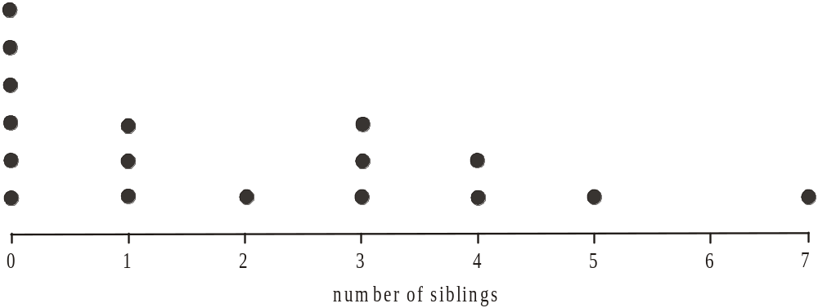

Question 1

The mode of this distribution is

- 0
- 1
- 2
- 6
- 7

Question 2

The mean of this distribution is

- 0
- 0.5
- 1
- 1.5
- 2

Question 3

The ordered stemplot below shows the distribution of the unemployment rate, expressed as a percentage, in 14 countries.

0 | 4
0 | 5 | 7 | 8 | 9
1 | 0 | 2 | 3 | 3 | 4
1 | 6 | 8 | 9
2
2 | 7

The interquartile range (IQR) of the unemployment rates in these 14 countries is

- 1
- 7.5
- 8
- 12
- 24

Question 4

The breathing rate of a large group of tertiary students is approximately normally distributed with a mean of 14 breaths/minute and a standard deviation of 0.8 breaths/minute.
The percentage of tertiary students with a breathing rate between 14 breaths/minute and 15.6 breaths/minute is

- 45%
- 47.5%
- 49.85%
- 95%
- 99.7%

Question 5

The mean head circumference (in cm) of a randomly chosen group of 10-year-old girls is 52cm and the standard deviation is 1.2cm.
A 10 year old girl has a head circumference of 50.5cm.
Her standardized head circumference (z score) relative to this group of 10-year-old girls is

- – 1.5
- – 1.25
- 0.3
- 1.25
- 1.5

Question 6

A study investigating the relationship between a student’s year level and their preferred method of contacting friends was conducted.
The percentage segmented bar chart below summarises the results.

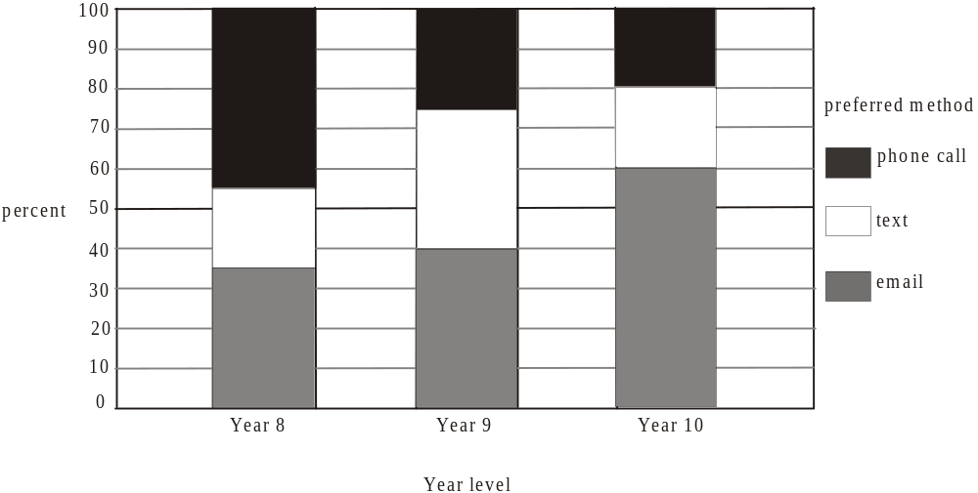

The percentage of Year 9 students whose preferred method is a text is

- 20%
- 25%
- 30%
- 35%
- 45%

The following information relates to Questions 7 and 8.

A group of ten men join a weight loss program. Their original body weight (in kg) together with their weight loss (in kg) is shown on the table below.

original body  weight  (kg) | weight  loss  (kg)
98 | 5
110 | 8
115 | 9
123 | 15
95 | 3
106 | 6
122 | 19
134 | 22
118 | 17
127 | 14

A scatterplot is constructed for this data and is shown below.

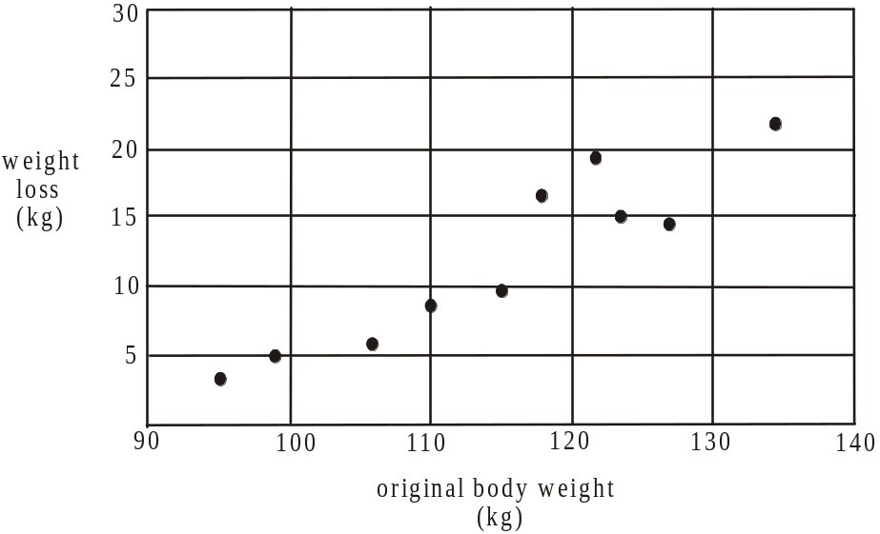

Question 7

The value of Pearson’s product-moment correlation coefficient for original body weight and weight loss is closest to

- – 0.9207
- – 0.8479
- 0.8479
- 0.9207
- 0.9596

Question 8

A least squares regression line is fitted to the data and is given by

This equation is used to predict the weight loss of the man with an original body weight of 115kg. The residual value (in kg) for this prediction is closest to

- – 29.45
- – 2.37
- 2.37
- 9
- 29.45

Question 9

The relationship between the variables size (small, medium, large, extra large, extra extra large) and number ordered is best displayed by

- a parallel boxplot
- a back-to-back stemplot
- a histogram
- a bar chart
- a scatterplot

Question 10

The quantity (in tonnes) of a raw material that is being imported and the cost (in $’s per tonne) of its importation on 12 separate occasions is displayed on the scatterplot below.

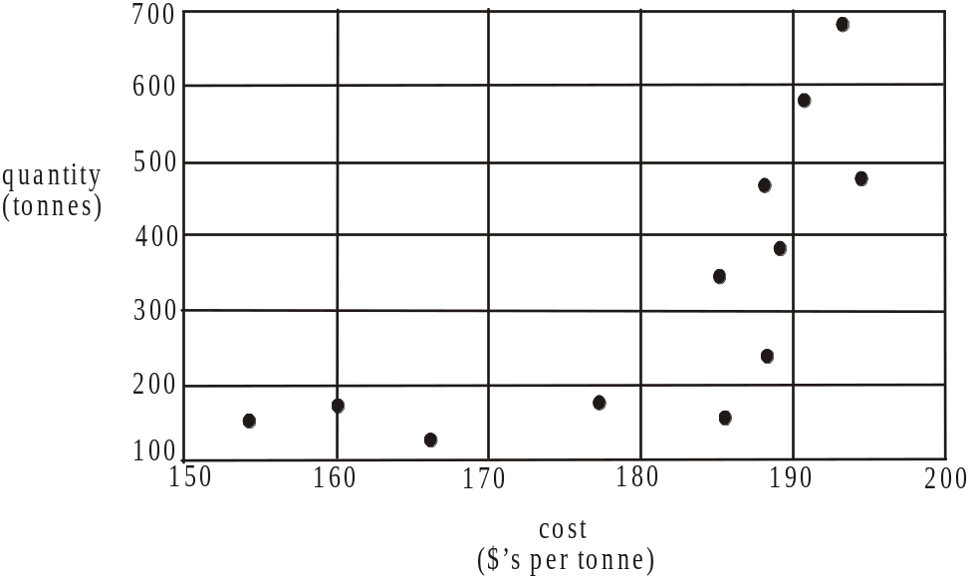

In an effort to linearise the data the plot should show

- quantity against 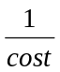

- quantity against 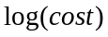

- (quantity)² against cost

- log(quantity) against cost

- (quantity)² against

The following information relates to Questions 11 – 13.

A time series plot is to be constructed using the data contained in the table below.

Month  number | Cost  ($)
1 | 58
2 | 92
3 | 123
4 | 136
5 | 151
6 | 162
7 | 159
8 | 139
9 | 172
10 | 180
11 | 185
12 | 179

Question 11

A least squares regression line is fitted to the time series plot so that the cost can be predicted by the month number.
The equation of this least squares regression line is

Question 12

Using a two-point moving mean with centring to smooth the data, the smoothed value for month number 8 is

- 152.25
- 156.67
- 158.32
- 160.88
- 165.5

Question 13

The data in the table is used to calculate the seasonal index for each month.
The seasonal index for month number 4 is closest to

- 0.81
- 0.85
- 0.94
- 1.04
- 1.06
SECTION B

Module 1: Number patterns

If you choose this module all questions must be answered.

Question 1

In an arithmetic sequence the second term is 14 and the fourth term is 30.
The first term is

- – 2
- 6
- 22
- 36
- 38

Question 2

The first three terms of a geometric sequence are 20, 12, 7.2,…
The fourth term is

- 1.2
- 3.6
- 3.82
- 4.32
- 4.8

Question 3

The difference equation 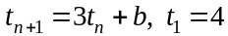 generates the sequence 4, 6, 12, 30,…
The value of b is

- – 8
- – 6
- – 4
- 2
- 6

Question 4

Keisha starts her cross-country running training by running 2km in the first week, 4.5km in the second week and 7km in the third week.
If she were to continue in this pattern, the total number of kilometers she would have run over 10 weeks would be

- 24.5
- 45
- 132.5
- 177.5
- 12 714

Question 5

Vince’s tomato crop is coming to an end. The number of tomatoes being produced is reducing by 20% each week.
He picked 26 tomatoes this week.
Including this week’s, the total number of tomatoes remaining in the crop is

- 31
- 33
- 55
- 112
- 130

Question 6

At the start of each day a recycling plant receives 10 tonnes of material to be recycled. Each day the plant is able to recycle 94% of the material present at the plant and the rest is left to be recycled the next day. The amount of material, in tonnes, needing to be recycled at the plant at the start of the n^{th} day just after the delivery is given by 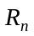.
A difference equation which describes this situation is

- 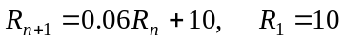
- 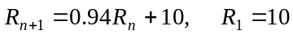
- 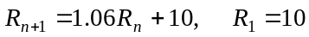
- 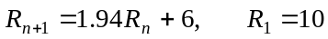
- 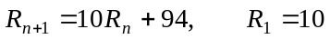

Question 7

The first five terms of a Fibonacci related sequence are 0,1,1,3,5,…
The difference equation that generates this sequence is

- 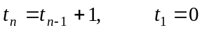
- 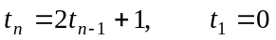
- 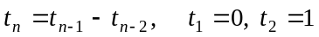
- 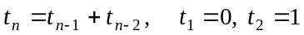
- 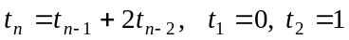
Question 8

The difference equation 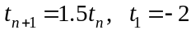 generates a sequence of numbers. The first five terms of that sequence could be represented graphically by
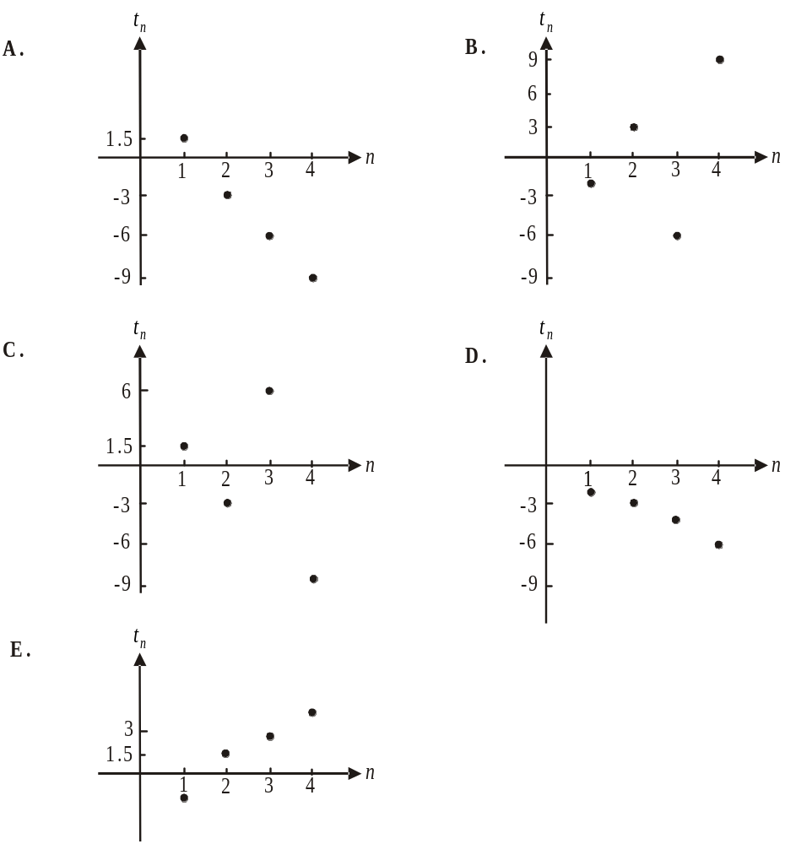

Question 9

After a flood, the height of a swollen river decreased by 2.4m on the first day, by 1.92m on the second day and by 1.536m on the third day. If the height of the river continued to decrease in this way, then during the second week after the flood, the height of the river would decreases in total by approximately

- 0.13 metres
- 0.5 metres
- 1.99 metres
- 9.48 metres
- 11.47 metres

Module 2: Geometry and trigonometry

If you choose this module all questions must be answered.

Question 1

The triangle below is an isosceles triangle.

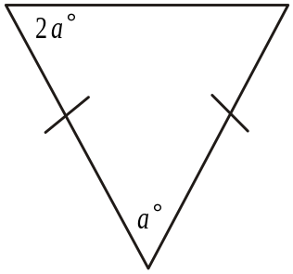

The value of a is

- 30
- 36
- 45
- 48
- 60

Question 2

A man lying on level ground at M observes a kite, K, flying at a horizontal distance of 200m and at a vertical distance of 40m from him.

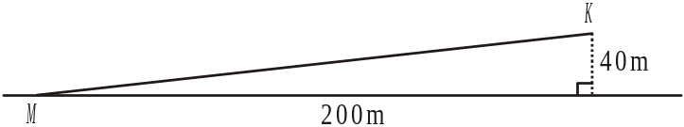

The angle of elevation of the kite from the man is closest to

- 0.2°
- 2°
- 11°
- 12°
- 79°

Question 3

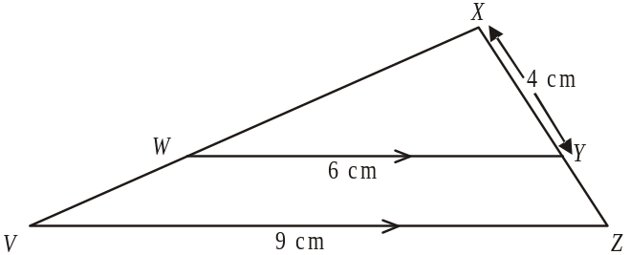

In the diagram above, VZ is parallel to WY,
The length, in cm, of YZ is

- 1.5
- 2
- 3
- 5
- 6

Question 4

The diagram below shows a block of timber in the shape of a square prism with sidelengths 5cm and length 40cm.
A cavity in the shape of a prism with a semicircular cross-section of radius 1.2cm and length 40cm is made in the block.

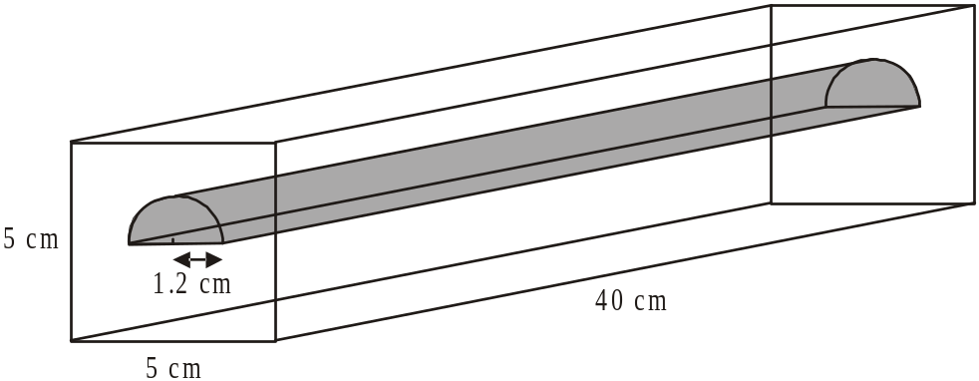

The volume of timber remaining, in cm³, is closest to

- 819
- 849
- 910
- 925
- 956

Question 5

The contour map below has a line AB drawn on it.

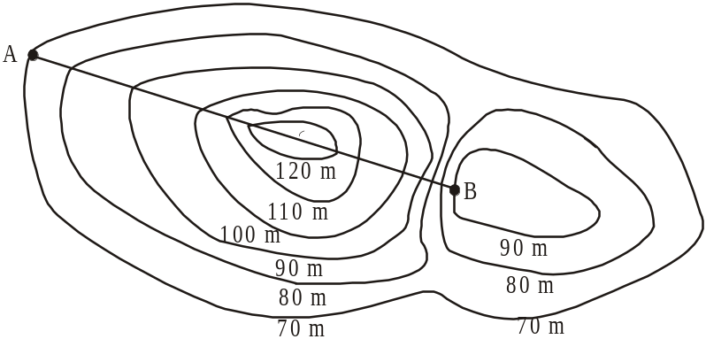

A cross-sectional profile that could represent the height of the land above sea level along the line AB is

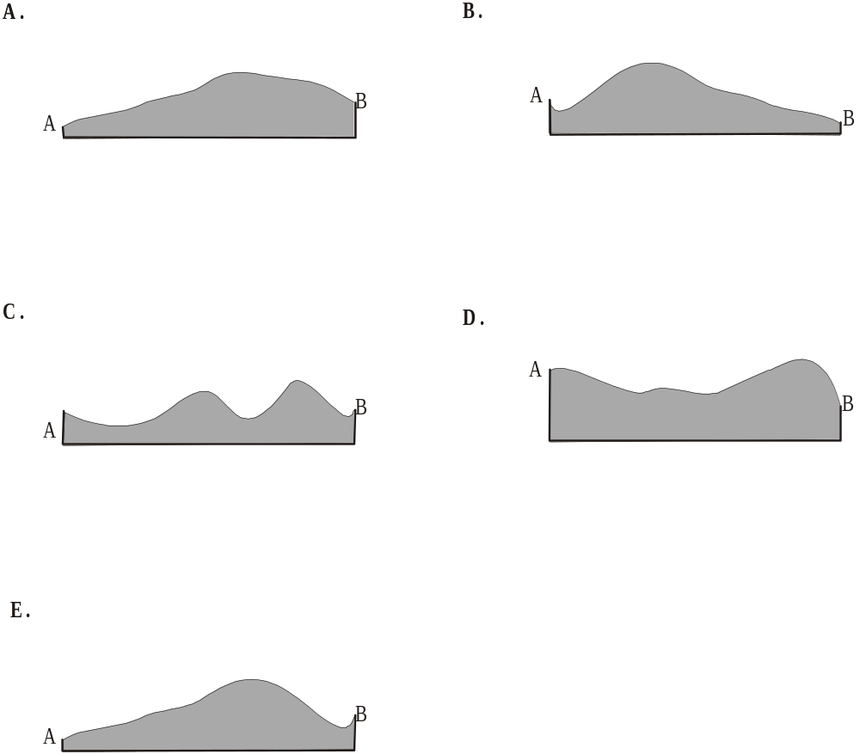

Question 6

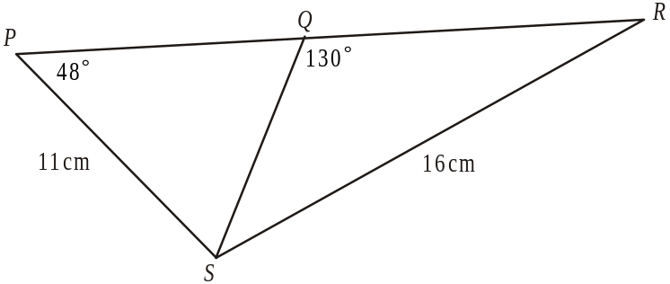

In the diagram above the point Q lies on the line PR. The length QS is equal to

- 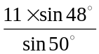

- 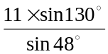

- 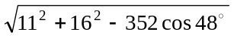

- 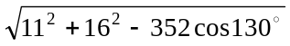

- 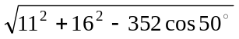

Question 7

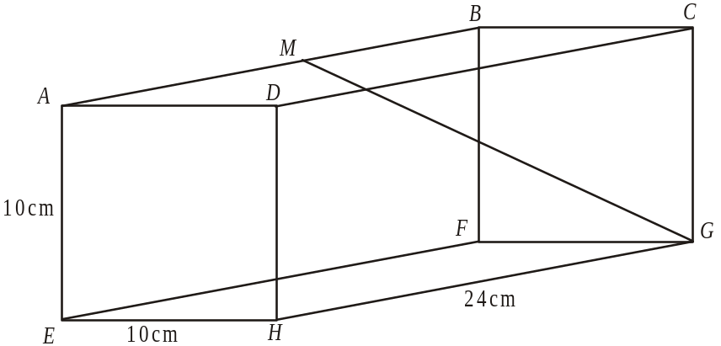

In the rectangular prism above, and M is the midpoint of AB.
The length of GM in cm, is closest to

- 12
- 13.2
- 14
- 15.6
- 18.5

Question 8

For the regular octagon shown below, O is the centre and .

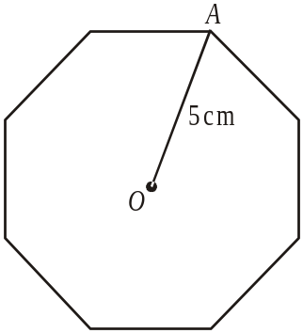

The area, in cm² of the octagon is closest to

- 9
- 63
- 71
- 100
- 142

Question 9

Three camp sites, A, B and C are established in bushland. The campsite at C is 8km due south of A. The camp site at B is 5.2km from A and 6.3km from C as indicated in the diagram below.
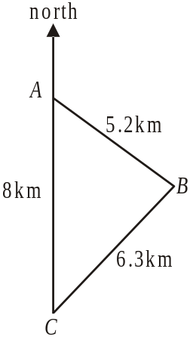

The bearing of B from A is closest to

- 052°
- 095°
- 110°
- 128°
- 142°

Module 3: Graphs and relations

If you choose this module all questions must be answered.

Question 1

The graph below shows the temperature inside an old refrigerator over a 24-hour period.

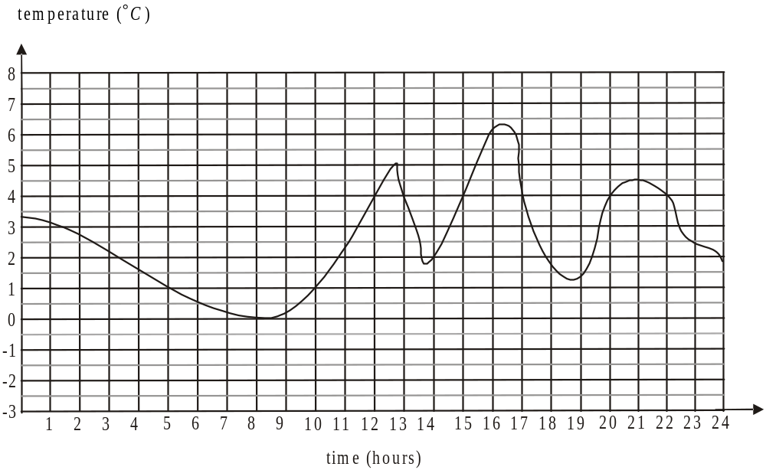

For safe food storage, the temperature range should be 1°C – 4°C.
The number of hours that food could be safely stored in this refrigerator over this 24-hour period was

- 5
- 8
- 10
- 14
- 15
The following information refers to Questions 2 and 3.

The cost C, in dollars, of a monthly membership at a gym is based on the number of classes x attended during the month. The graph below shows the cost of a monthly membership at this gym.
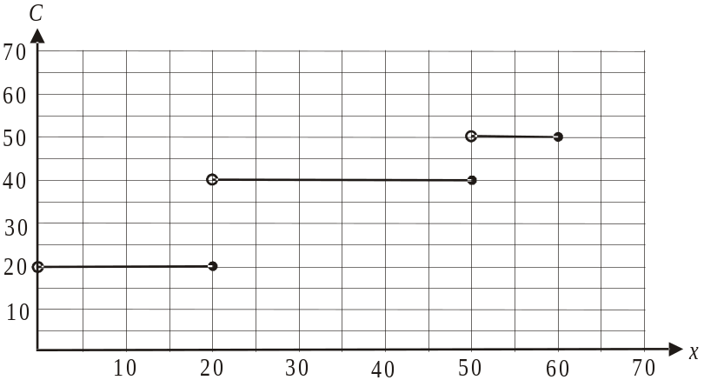

Question 2

Joan pays the monthly membership for both of her daughters. One daughter attends 18 classes per month and the other attends 50. The amount Joan pays each month is

- $20
- $40
- $50
- $60
- $70

Question 3

A rule that could be used to describe this graph is

- 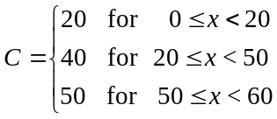
- 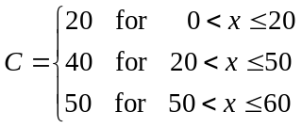
- 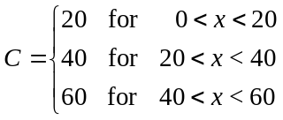
- 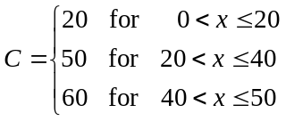
- 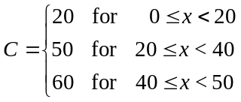

Question 4

Glenda bought 1kg of bananas and 3 punnets of strawberries for a total cost of $9.
At the same green grocer, Mark bought 2kg of bananas and 2 punnets of strawberries for a total cost of $10.
At this green grocer a punnet of strawberries costs

- $1
- $2
- $2.50
- $3
- $3.50

Question 5

An importer receives a consignment of CD players. He has a fixed cost of $1800 for the consignment plus a cost of $80 for each CD player.
If he sells each CD player for $100 he will break even.
The number of CD players in the consignment is

- 18
- 20
- 90
- 120
- 180

Question 6

Two lines intersect at the point 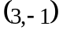.
The equation of one of these lines could be

- 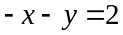
- 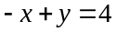
- 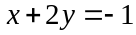
- 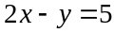
- 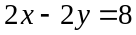

Question 7

An interstate school trip is being organised for Year 10 and 11 students. In order for the trip to go ahead there must be

- a maximum of 30 students
- a minimum of 10 students
- at least twice as many Year 11 students as Year 10 students

Let x represent the number of Year 10 students going on the trip.
Let y represent the number of Year 11 students going on the trip.

The shaded region that represents the feasible region for this problem is

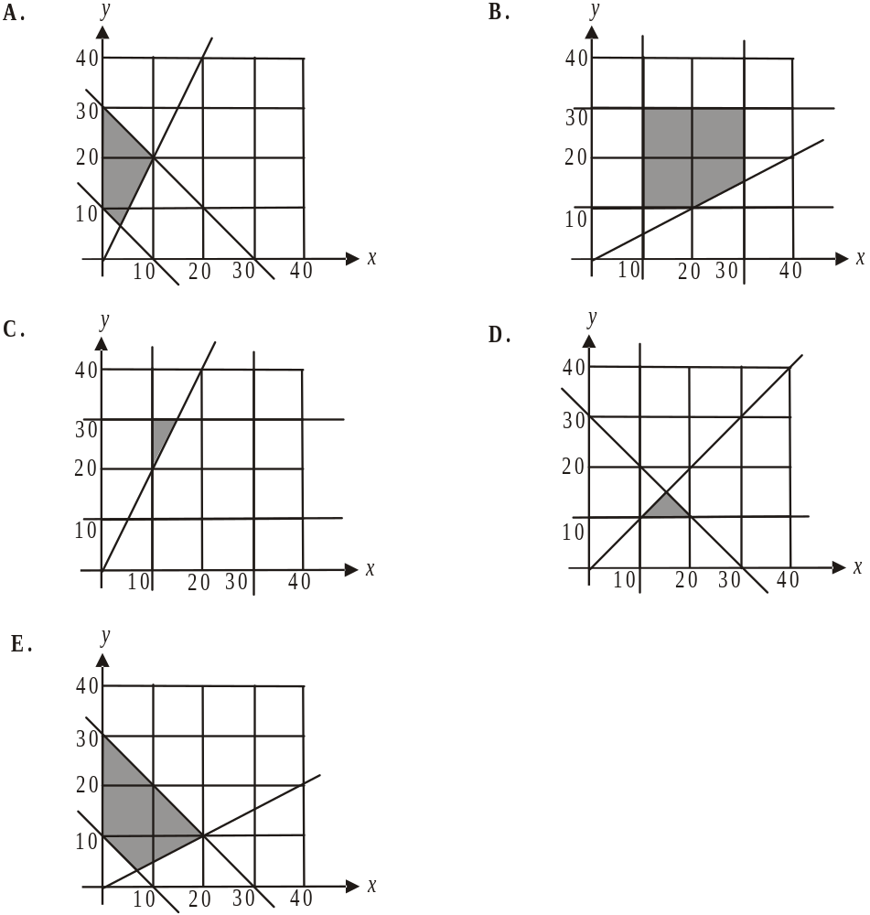

Question 8

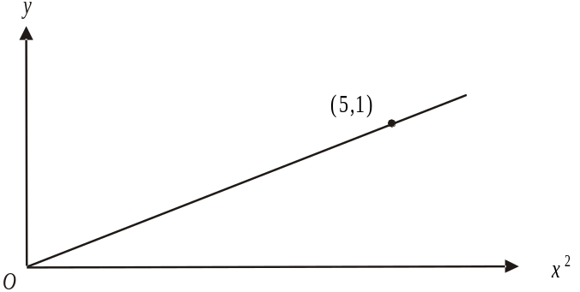

The graph above shows the relationship between 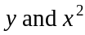. The graph showing the same relationship between y and x is

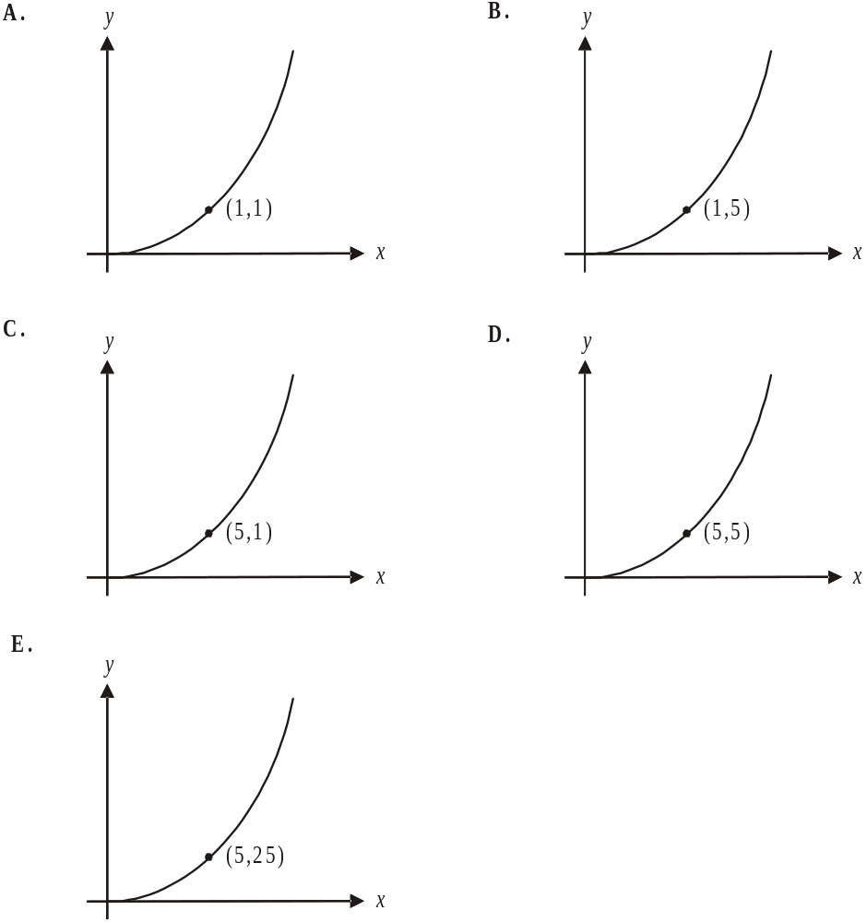

Question 9

At a warehouse sale a wholesaler sells 400 lipsticks for $3 each and makes a profit of $1 on each. The wholesaler’s costs include a fixed cost of $x and a cost on each of the lipsticks of $1.50.
The value of x is

- 1.5
- 2
- 200
- 600
- 800

Module 4: Business-related mathematics

If you choose this module all questions must be answered.

Question 1

Jarrod’s bank statement for April is shown below.

Date | Transaction details | Withdrawals | Deposits | Balance
01 Apr | Opening balance |  |  | 522.31
07 Apr | Deposit – cash |  | 460.00 | 982.31
15 Apr | Withdrawal – ATM | 160.00 |  | 822.31
23 Apr | Withdrawal – funds transfer | 272.40 |  | 549.91
30 Apr | Closing balance |  |  | 549.91

Jarrod receives interest on this account calculated at the rate of 0.2% per month on the minimum monthly balance. In April, the interest Jarrod received was

- $1.04
- $1.10
- $1.37
- $1.64
- $2.61

Question 2

Will invested $8 000 in an account that earned simple interest of 4.5% per annum.
At the end of the investment he received $1 440 in interest.
Will had his money invested for

- 2 years
- 2.2 years
- 4 years
- 6 years
- 8.1 years

Question 3

The price paid for a dress was $275. This price included 10% GST (Goods and Service Tax).
The amount of GST included in this price was

- $2.75
- $25.00
- $27.50
- $30.56
- $75.00

Question 4

Greta invests $2 500 at a compound interest rate of 6% per annum calculated monthly.
After 10 years, the amount of interest she would have earned is

- $2048.49
- $2625.05
- $2627.85
- $3241.61
- $4548.49

Question 5

A business purchased a document shredder for $1 250. The value of the shredder depreciates at a rate of 2 cents per page shredded.
When the document shredder reached a book value of zero dollars, the number of pages it would have shredded would have been

- 625
- 2 500
- 6 250
- 25 000
- 62 500

Question 6

A private health fund increased its premiums by the rate of inflation only for the last two years. Inflation ran at 2% per annum in each of the last two years.
Angela’s premium this year was $540. Two years ago Angela’s premium was

- $517.68
- $518.40
- $518.62
- $519.03
- $561.82

Question 7

Brad purchases a bed for $1100. He pays a deposit of $300 and quarterly repayments of $230 for one year.
The effective interest rate that Brad will be paying is approximately

- 11%
- 15%
- 17%
- 21%
- 24%

Question 8

A sum of $45 000 is invested in an annuity that earns interest of 6.4% per annum compounding quarterly. This annuity is to last for 15 years. The annual sum that this annuity pays is

- $1 172.28
- $1 380.35
- $3 398.21
- $4 689.13
- $5 249.16

Question 9

Ryan took out a home loan of $340 000. The loan; to be repaid over 25 years, has an interest rate of 7.6% per annum calculated quarterly on the reducing balance of the loan. Ryan will make equal quarterly repayments over the course of the loan.
The total amount of interest he will pay on the loan is closest to

- $90 279
- $422 025
- $430 279
- $631 420
- $762 020
Module 5: Networks and decision mathematics

If you choose this module all questions must be answered.

Question 1
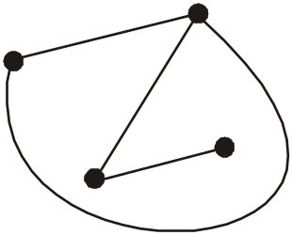

The graph shown above can be correctly described as

- connected but not planar
- connected but not simple
- complete but not connected
- complete but not planar
- simple but not complete

Question 2

The network below shows the distances, in kilometres, of bike tracks that run between the west gate and the east gate of a large park.

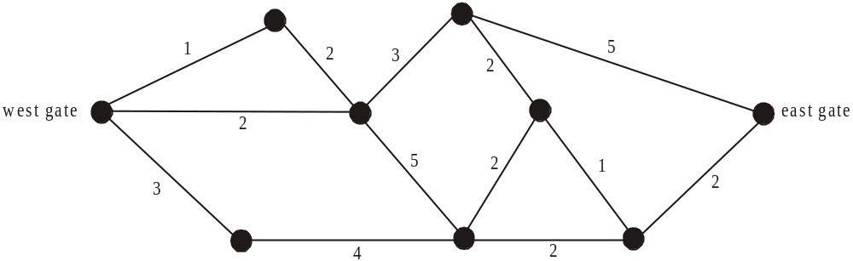

The length in kilometres, of the shortest route between the west gate and the east gate is

- 7
- 8
- 9
- 10
- 11
Question 3

A connected, planar graph has 7 vertices and 12 edges.
The number of faces that this graph has is

- 7
- 9
- 17
- 19
- 21

Question 4
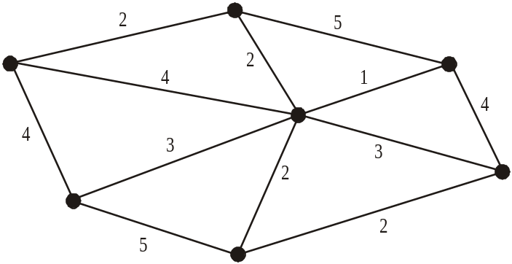

For the network above, the total weight of the minimal spanning tree will be

- 10
- 12
- 15
- 20
- 37

Question 5
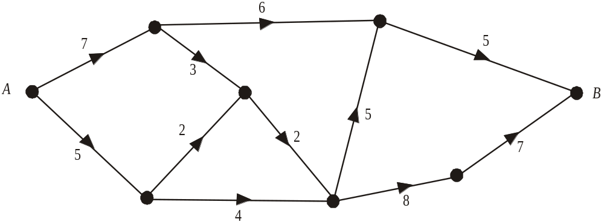

For the graph above the maximum flow possible through the network from A to B is

- 9
- 10
- 11
- 12
- 13
Question 6

Four manufacturers have been asked to provide the wholesale cost of producing 4 items for a large hardware distributor.
Each manufacturer will be allocated one item so that the total cost to the distributor is minimised.

Manufacturer | Item
Manufacturer | 1 | 2 | 3 | 4
A | 12 | 8 | 8 | 12
B | 11 | 10 | 9 | 10
C | 8 | 12 | 9 | 7
D | 10 | 9 | 11 | 7

That total minimum cost will be

- $31
- $32
- $34
- $37
- $38

Question 7

Which one of the following graphs does Euler’s formula involving faces, edges and vertices not apply to?

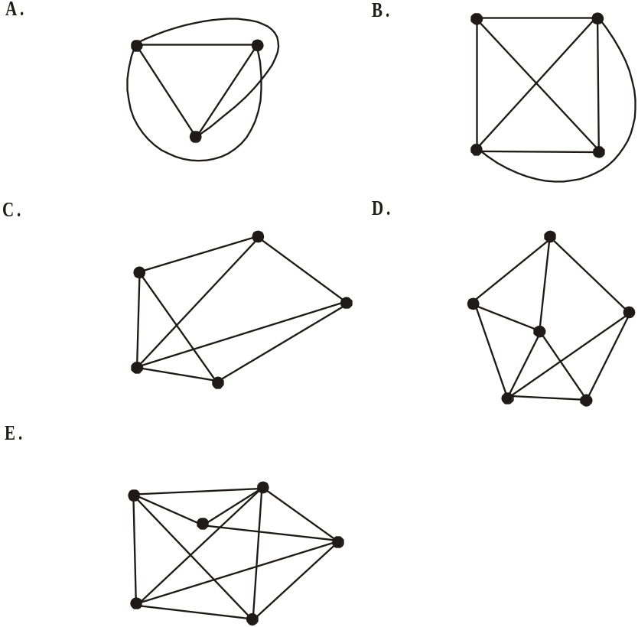

The following information below relates to Questions 8 and 9.

The activities together with the time, in weeks, needed to complete them for a particular project are shown on the network below.

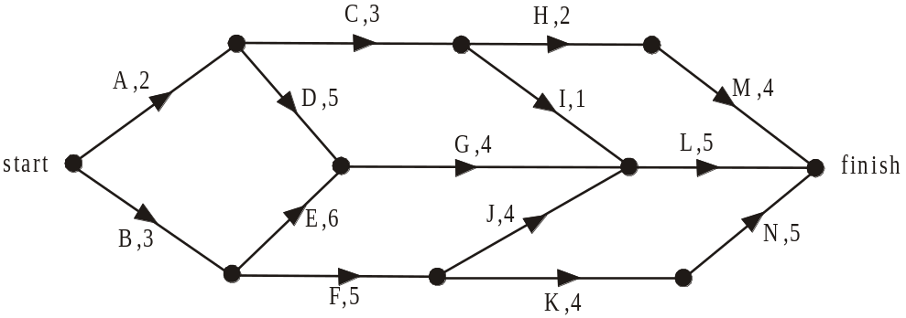

Question 8

The critical path for this project is

- A,C,H,M
- A,D,G,L
- B,E,G,L
- B,F,J,L
- B,F,K,N

Question 9

The event that will cause an extra four activities to become critical to the completion of the project is

- Activity D is decreased by 1 day
- Activity F is increased by 1 day
- Activity J is increased by 1 day
- Activity K is increased by 1 day
- Activity N is decreased by 1 day

Module 6: Matrices

If you choose this module all questions must be answered.

Question 1

For the matrix 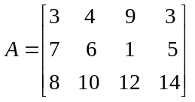 the element 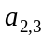 is

- 1
- 4
- 6
- 10
- 12

Question 2

Which one of the following does not equal 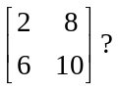

- 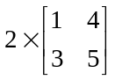

- 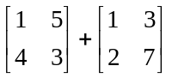

- 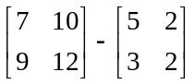

- 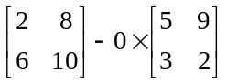

- 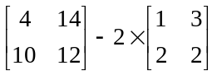

The following information relates to Questions 3 and 4.

The number of Prep – Year 2 students at reading levels 1A, 2A and 3A is shown in the table below.
Year level | Reading level
Year level | 1A | 2A | 3A
Prep | 14 | 4 | 1
1 | 26 | 9 | 4
2 | 12 | 20 | 7

Question 3

A matrix showing the reading levels of Year 2 students is

- 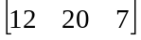

B. 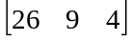

C. 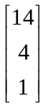

D. 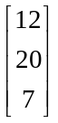

E. 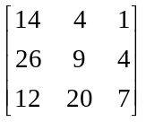

Question 4

The teacher time, in minutes, that should be allocated to students at each of the levels each week is shown in the matrix below.

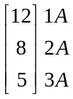

What is the total teacher time in minutes that should be allocated in a week to the Year 1 students?

- 25
- 205
- 339
- 404
- 690

Question 5

For the matrix equation , matrix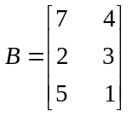.
If matrix X is a square matrix then the order of matrix A is

- 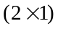
- 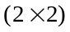
- 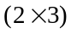
- 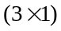
- 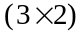

Question 6

The solution to the matrix equation

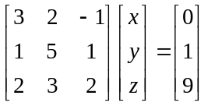

is given by
B. 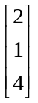
- 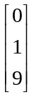

C. 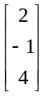
D. 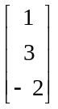

E. 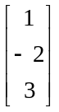

Question 7

A research company records the viewing habits of a large group of people who watch one of three 6pm news bulletins available on channels A, B and C. The following transition diagram shows the percentages who stay with the same channel the next night or move to another channel.
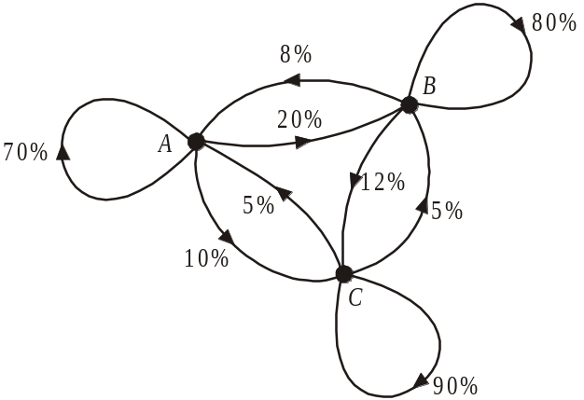

A corresponding transition matrix could be
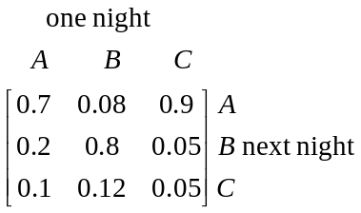
- 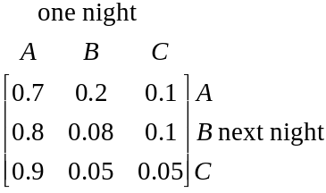 B.

C. 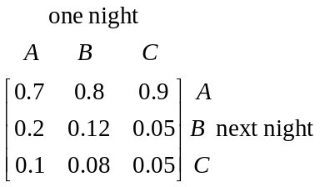 D. D.
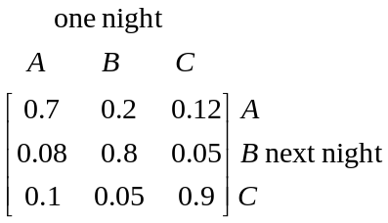

E. 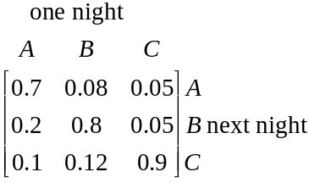
Question 8

Secondary students who wished to attend an outdoor camp had to attend one session a week in either running, weights or swimming. Teachers noticed over time that 90% of students who attended a particular session one week attended the same session the next week.
They also noticed that
- 3% who attended weights one week attended running the next
- 4% who attended running one week attended swimming the next
- 5% who attended swimming one week attended weights the next

A transition matrix that could represent this information is

- 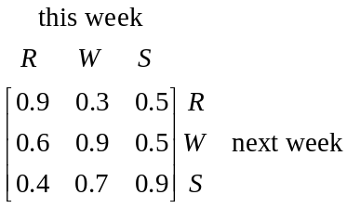 B.
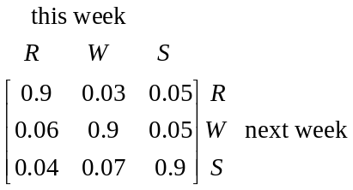

C. 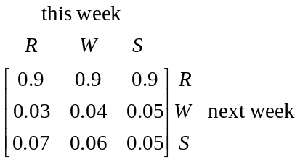 D. D.
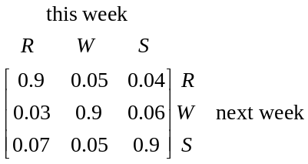

E. 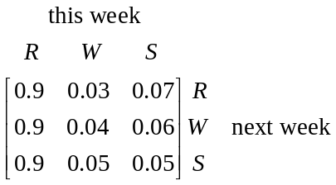

Question 9

Campers who holiday each year near a remote beach can stay at two sites A and B.
The Parks Service who register each campers stay, develop a transition matrix T to try and predict where the campers will stay in future years.

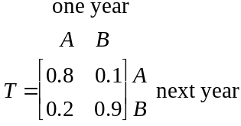
In 2009 there were a total of 200 campers at the sites and 120 of these were at site A.
The number of campers expected to be camping at site B in 2010 is

- 76
- 80
- 96
- 98
- 104
Further Mathematics Formulas

Core: Data analysis
standardised score: 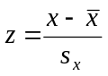
least squares line: 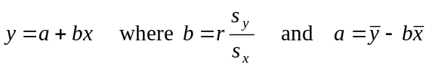
residual value: residual value = actual value – predicted value

seasonal index: seasonal index 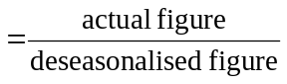

Module 1: Number patterns
arithmetic series: 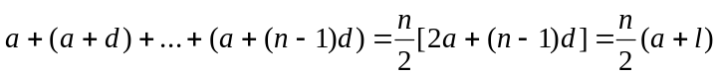
geometric series: 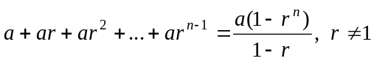
infinite geometric series: 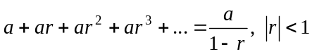

Module 2: Geometry and trigonometry
area of a triangle: 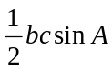
Heron's formula: 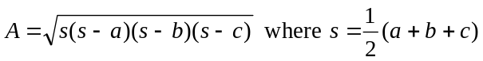
circumference of a circle: 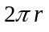
area of a circle: 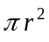
volume of a sphere: 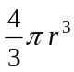
surface area of a sphere: 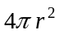
volume of a cone: 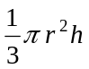
volume of a cylinder: 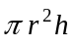
volume of a prism: 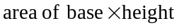
volume of a pyramid: 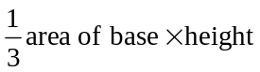

Reproduced with permission of the Victorian Curriculum and Assessment Authority, Victoria, Australia.
These formula sheets have been copied in 2010 from the VCAA website www.vcaa.vic.edu.au
The VCAA publish an exam issue supplement to the VCAA bulletin.
Pythagoras’ theorem 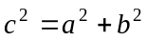
sine rule: 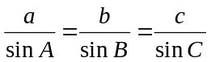
cosine rule: 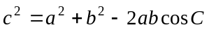

Module 3: Graphs and relations

Straight line graphs
gradient (slope): 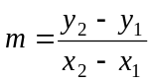
equation: 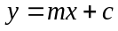

Module 4: Business-related mathematics

simple interest: 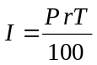
compound interest: 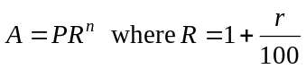
hire purchase: 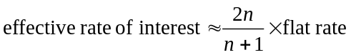

Module 5: Networks and decision mathematics

Euler’s formula: 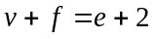

Module 6: Matrices

determinant of a 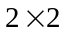 matrix 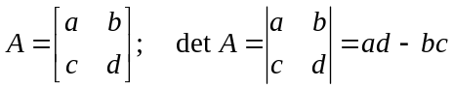
inverse of a matrix 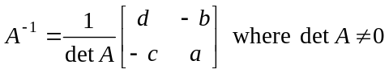

END OF FORMULA SHEET

Reproduced with permission of the Victorian Curriculum and Assessment Authority, Victoria, Australia.
These formula sheets have been copied in 2010 from the VCAA website www.vcaa.vic.edu.au
The VCAA publish an exam issue supplement to the VCAA bulletin.

